**EXPERIMENT-6**

**Problem Statement**

Develop a machine learning method to predict stock price based on past price variation.

**Algorithm**

Random forest is a flexible, easy to use [machine learning algorithm](https://builtin.com/data-science/introduction-to-machine-learning) that produces, even without hyper-parameter tuning, a great result most of the time. It is also one of the most used algorithms, because of its simplicity and diversity (it can be used for both classification and regression tasks). In this post we'll learn how the random forest algorithm works, how it differs from other algorithms and how to use it.

One big advantage of random forest is that it can be used for both classification and regression problems, which form the majority of current machine learning systems. Let's look at random forest in classification, since classification is sometimes considered the building block of machine learning. Below you can see how a random forest would look like with two trees:

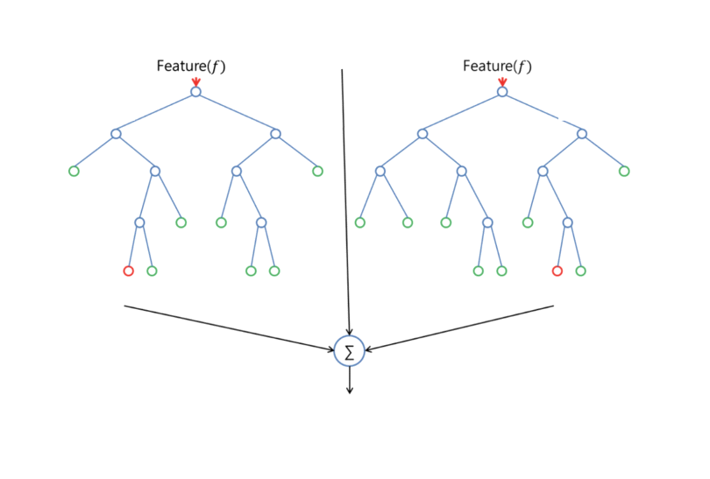

Random forest has nearly the same hyperparameters as a decision tree or a bagging classifier. Fortunately, there's no need to combine a decision tree with a bagging classifier because you can easily use the classifier-class of random forest. With random forest, you can also deal with regression tasks by using the algorithm's regressor.

**Program Snippet**

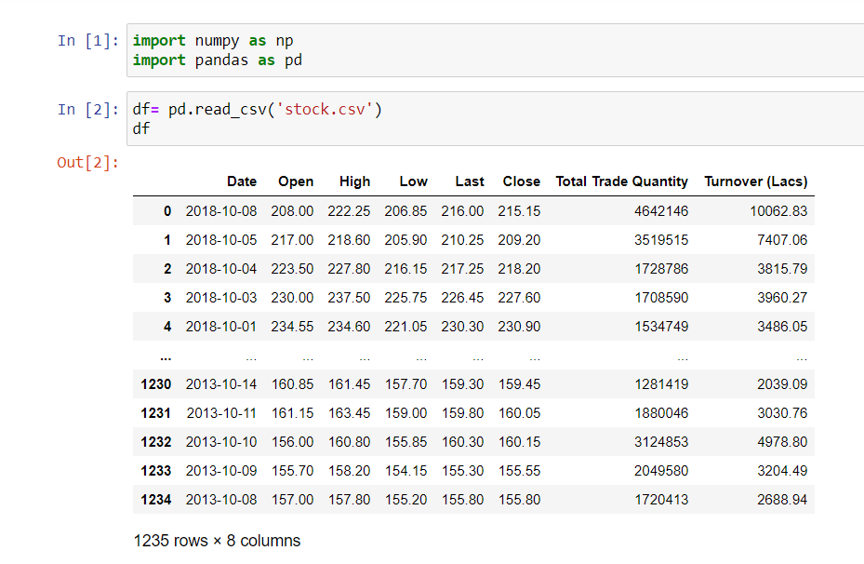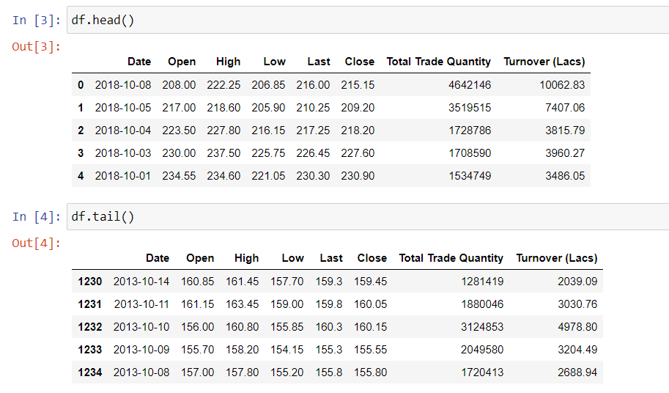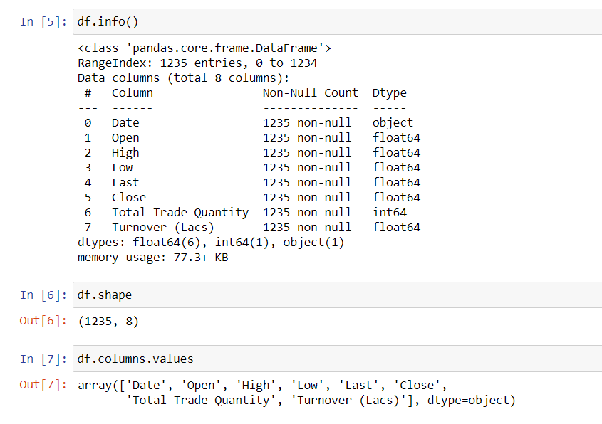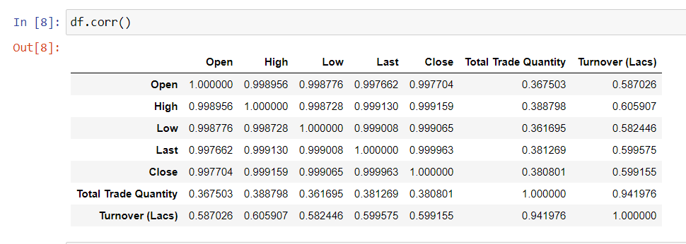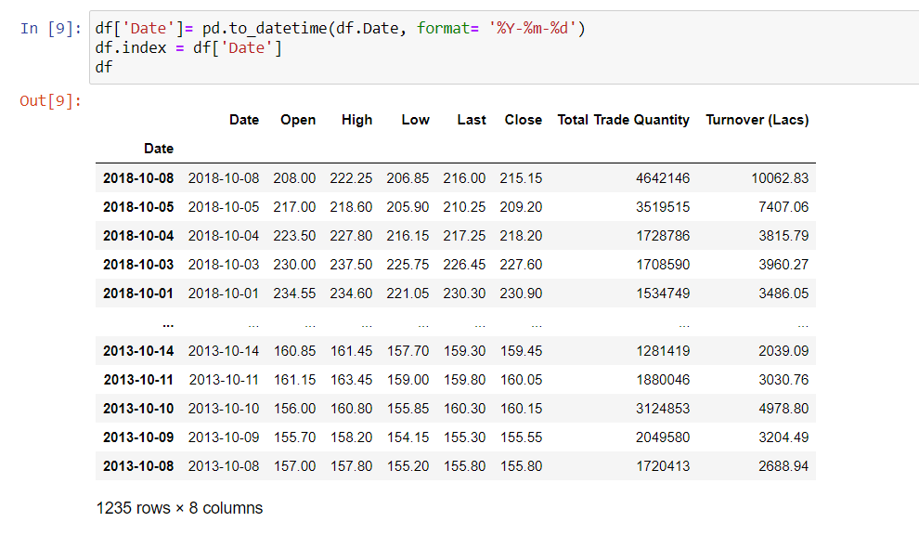

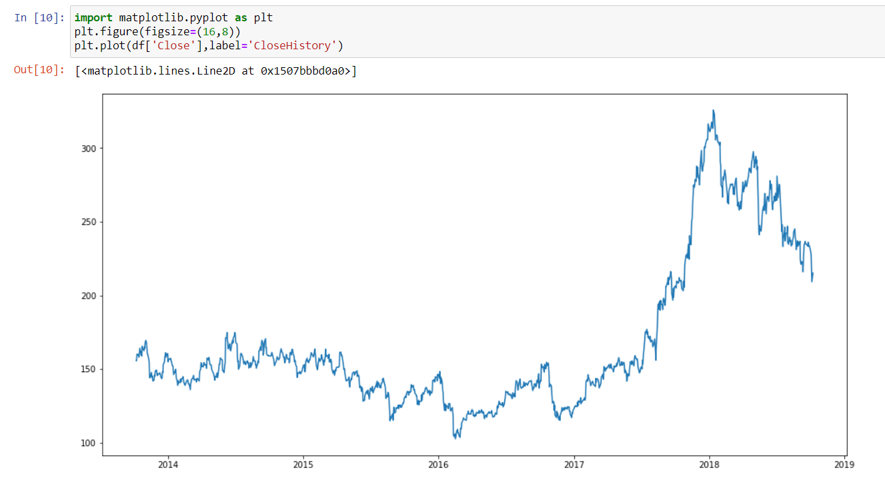

**Long Short Term Memory (LSTM)**

LSTMs are widely used for sequence prediction problems and have proven to be extremely effective. The reason they work so well is because LSTM is able to store past information that is important, and forget the information that is not. LSTM has three gates:

The input gate: The input gate adds information to the cell state

The forget gate: It removes the information that is no longer required by the model

The output gate: Output Gate at LSTM selects the information to be shown as output

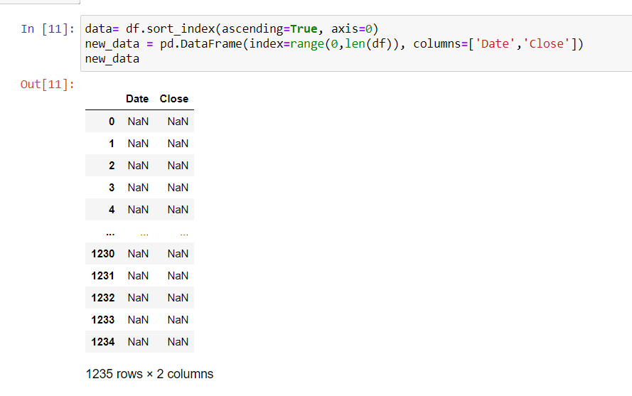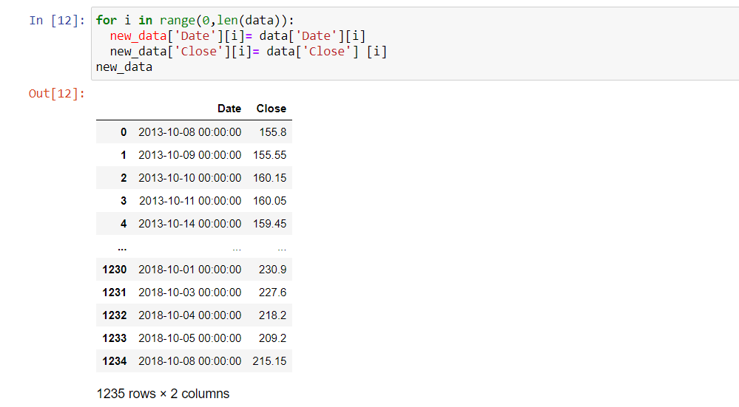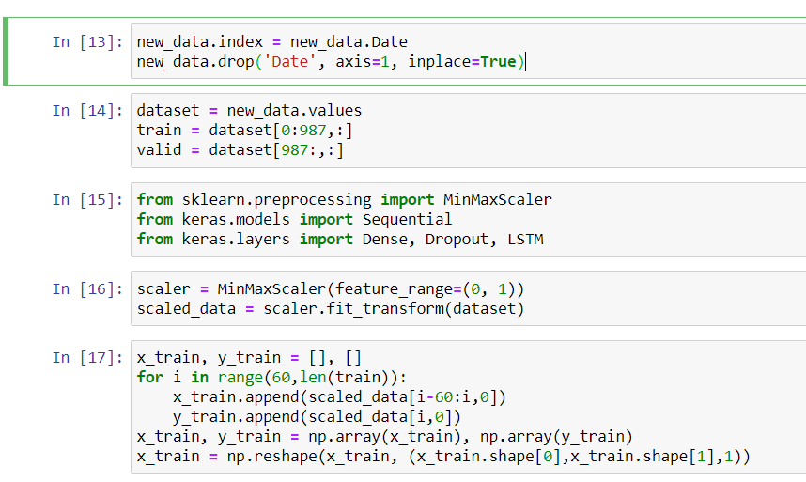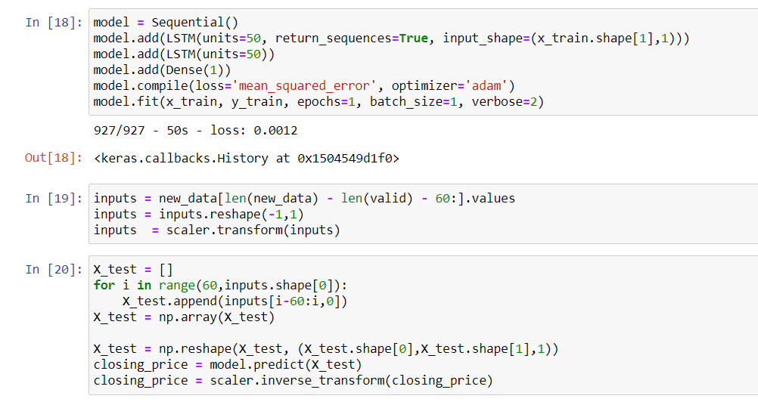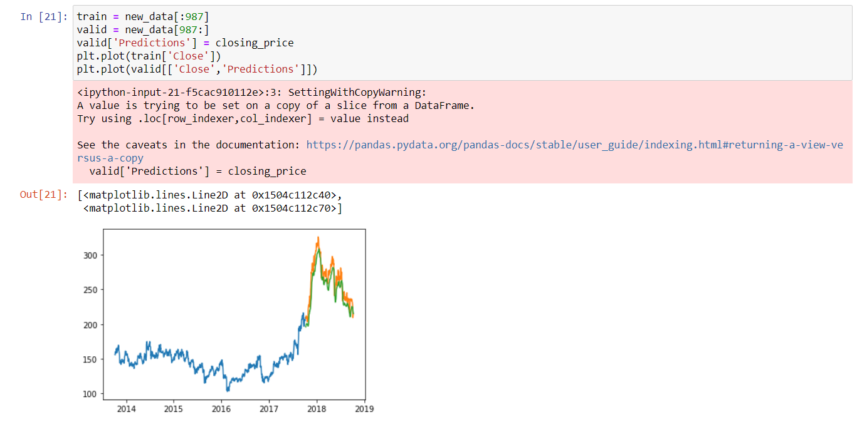

**Github link-**

<https://github.com/Damansandhu23/MLpracfile.git>